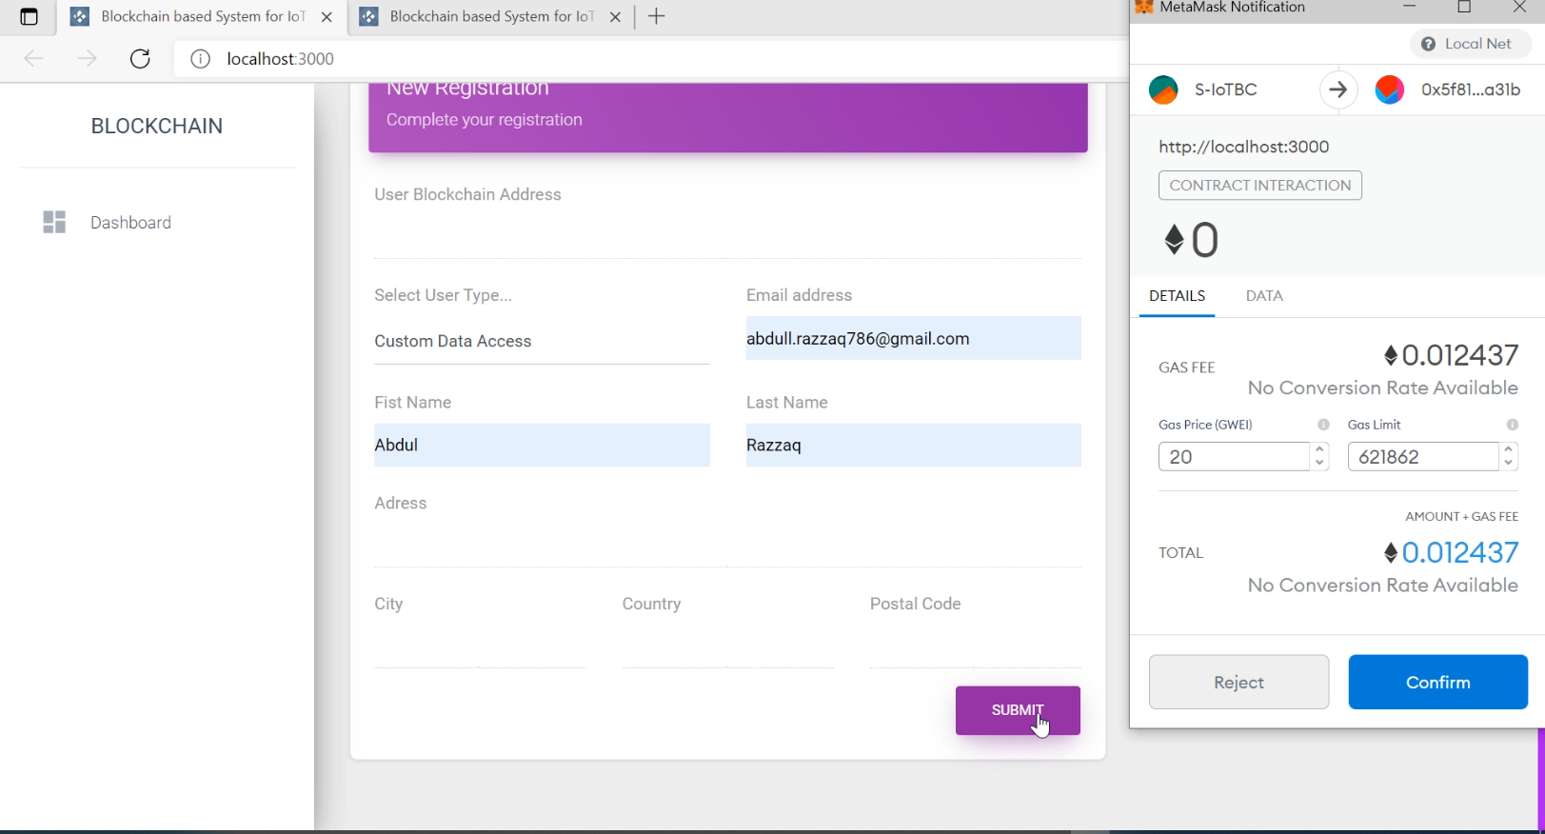

Registration page to be Custom Data User or To be Data Owner

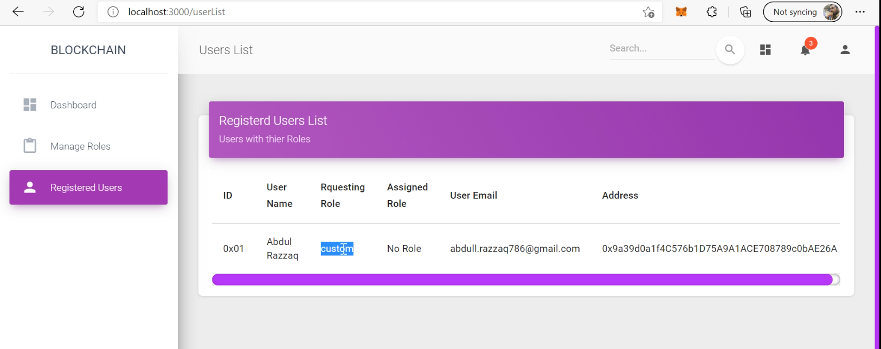

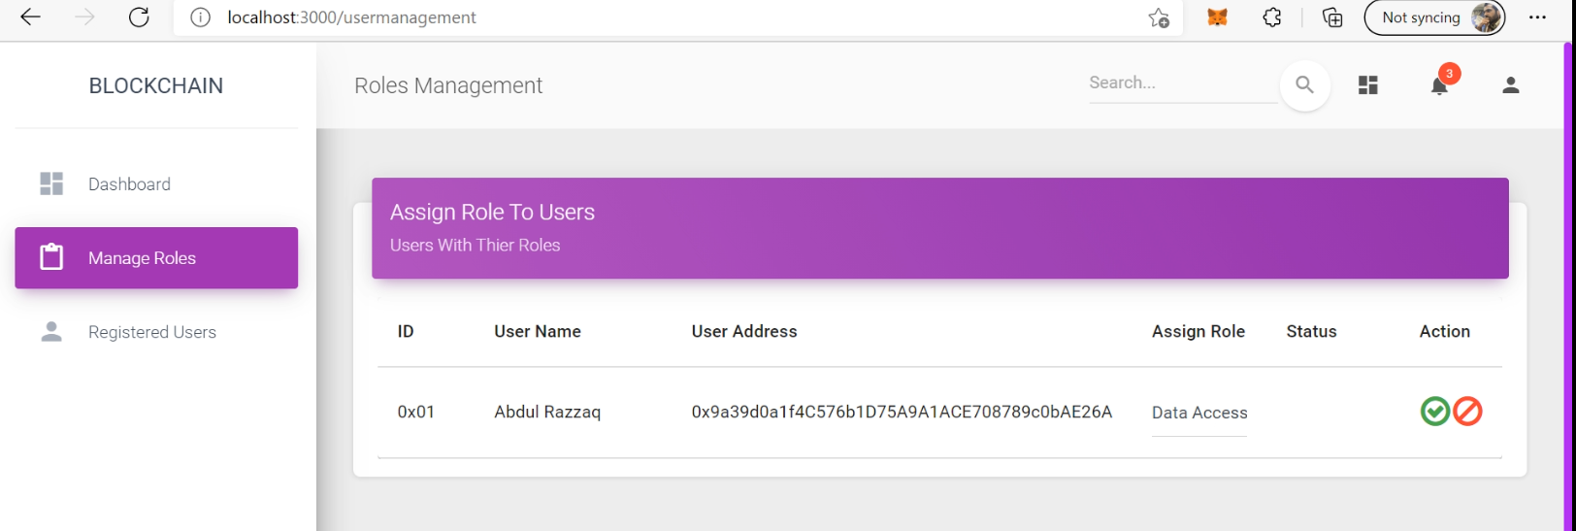

User Management

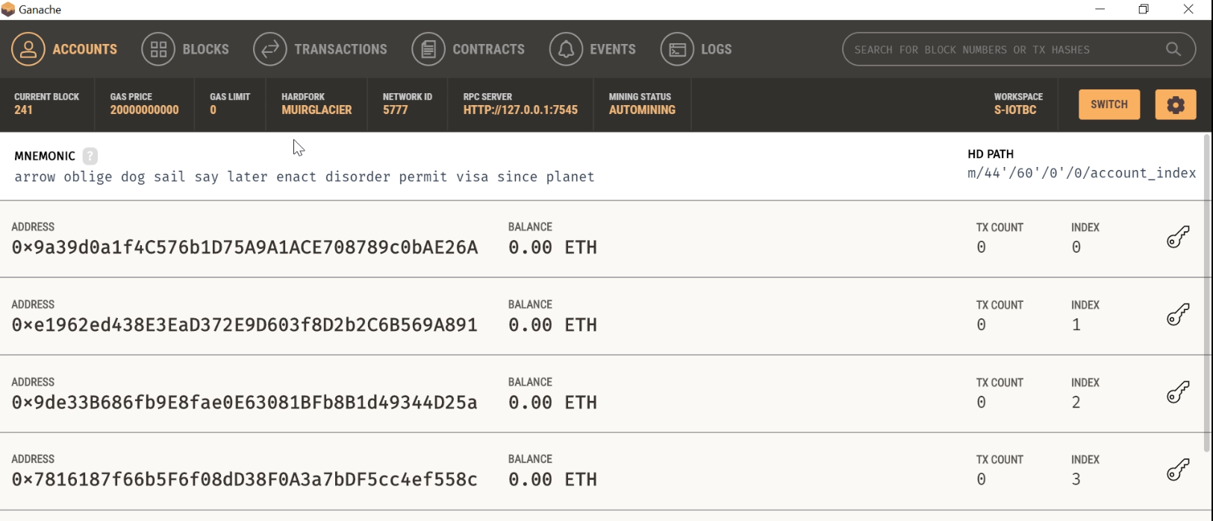

Ganache for making blockchain local environment

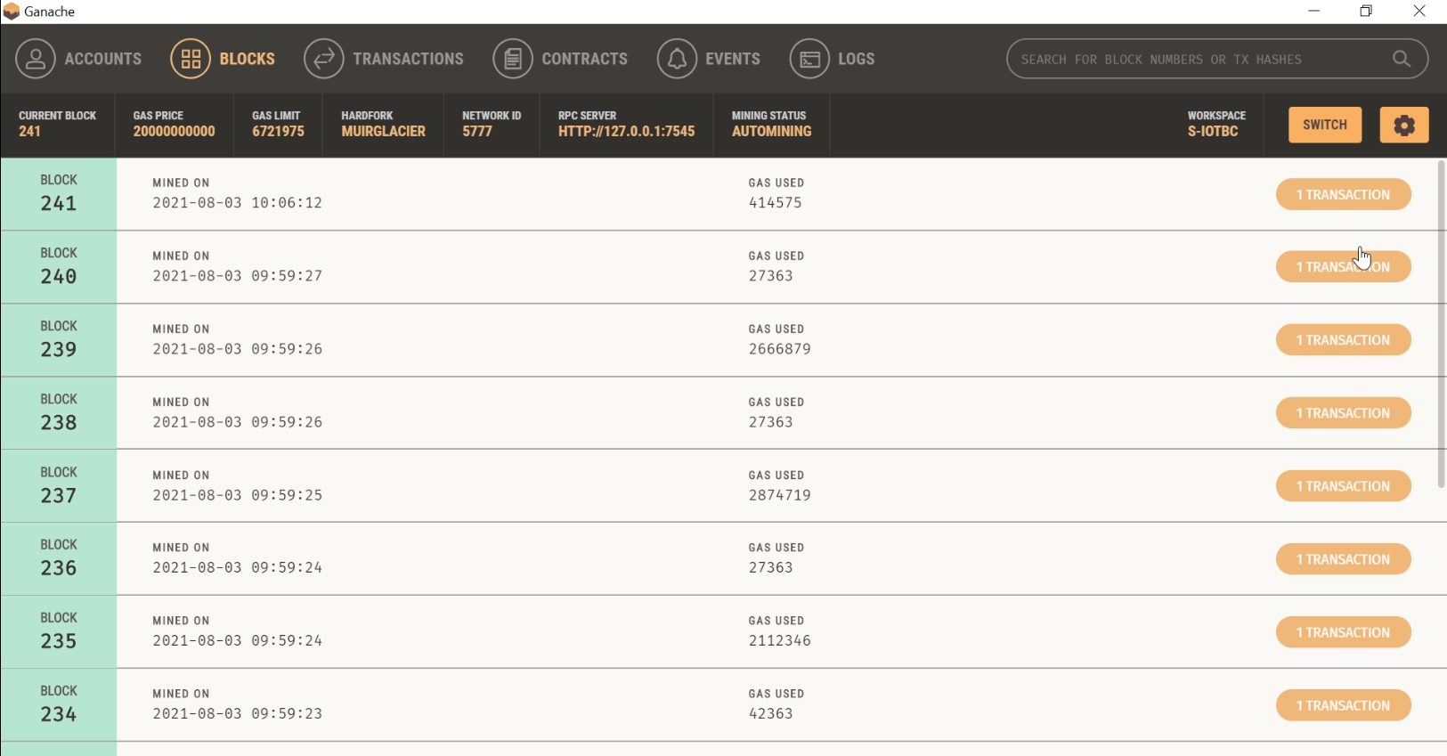

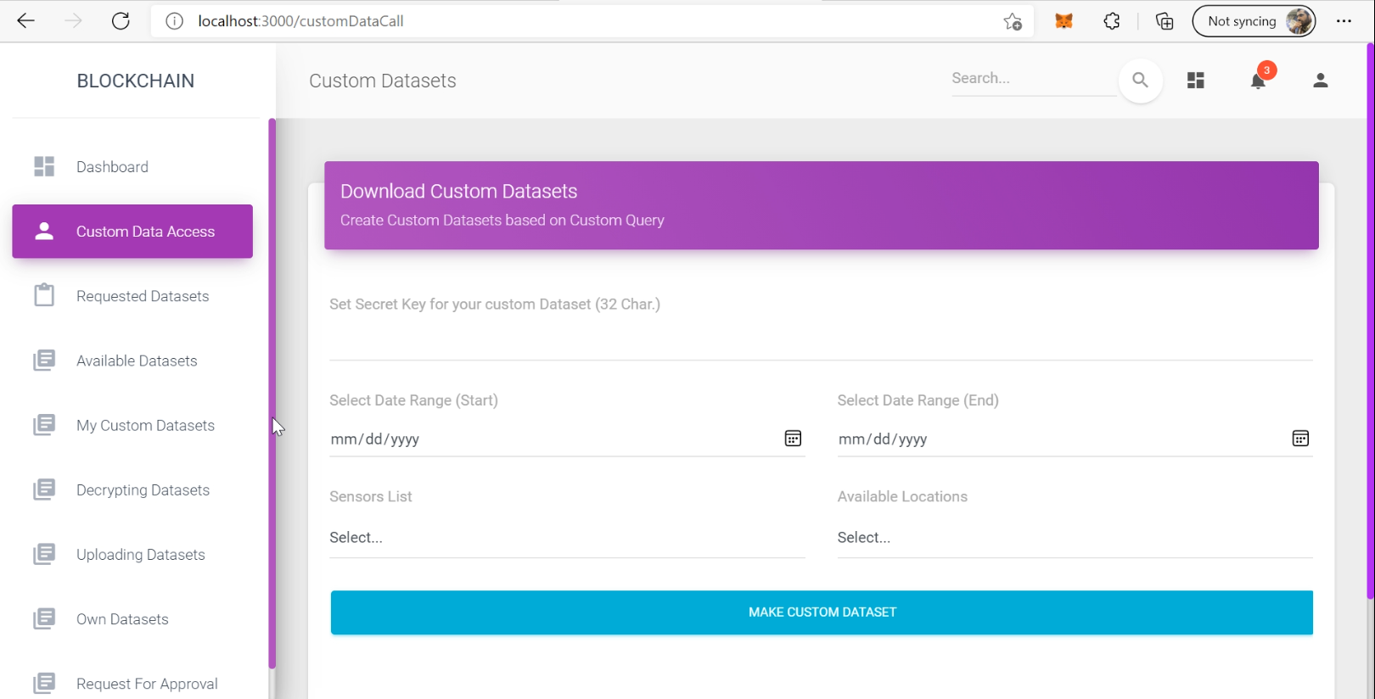

Custom Data call from database server and securing by key with AES and RSA

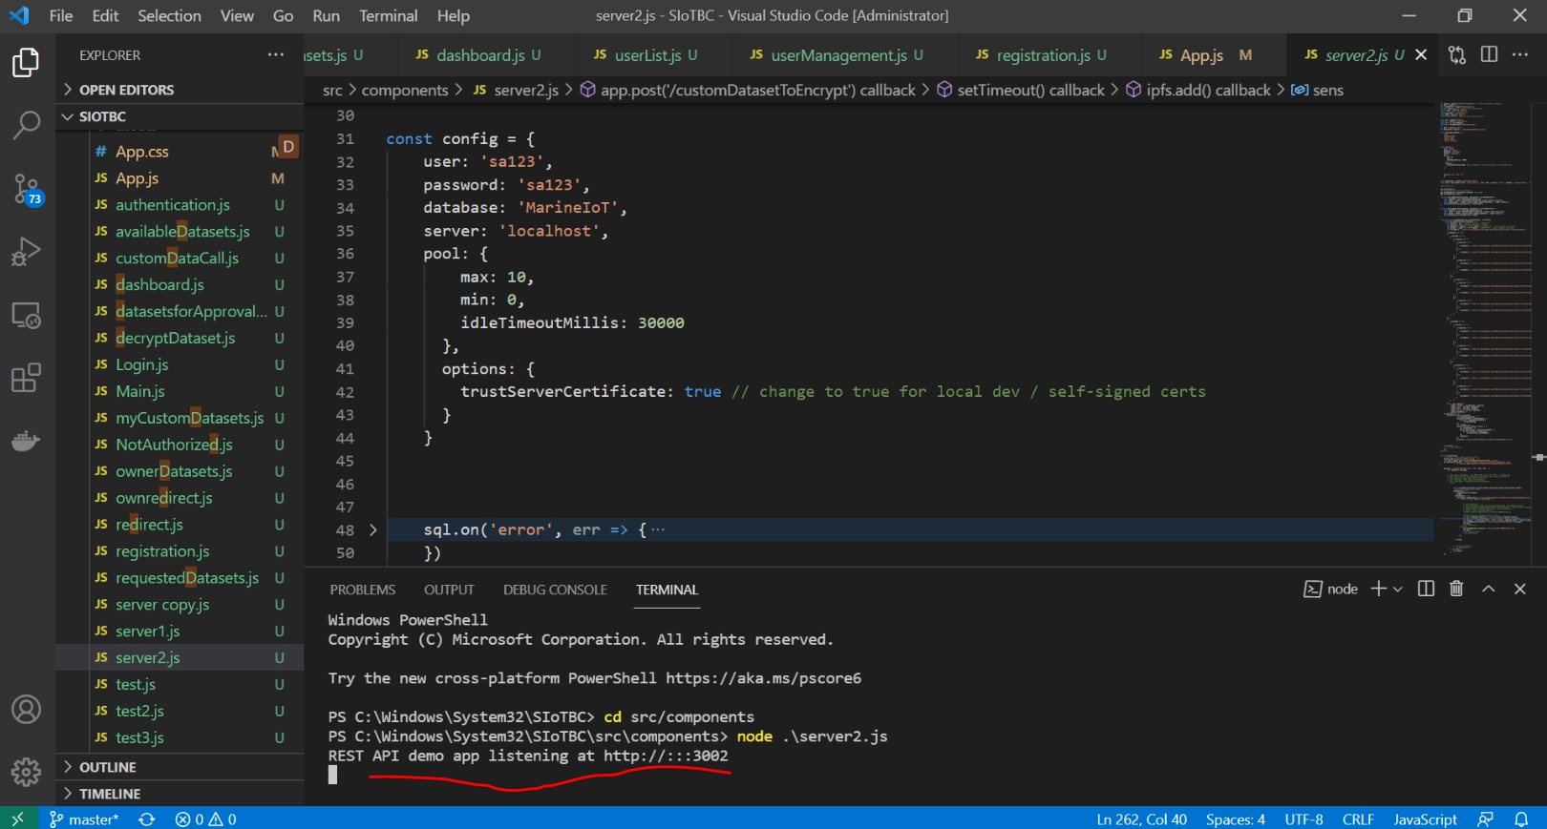

Running server

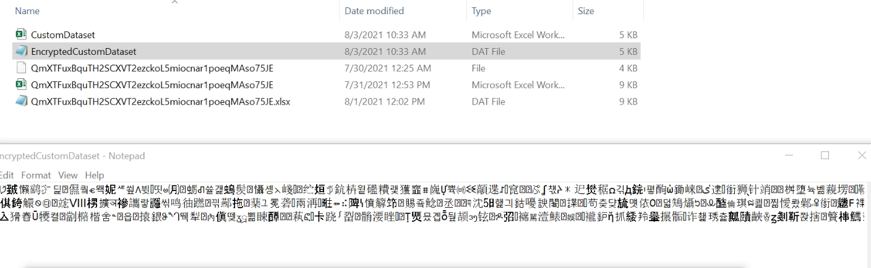

Dataset created in the form on asymmetric encryption using AES

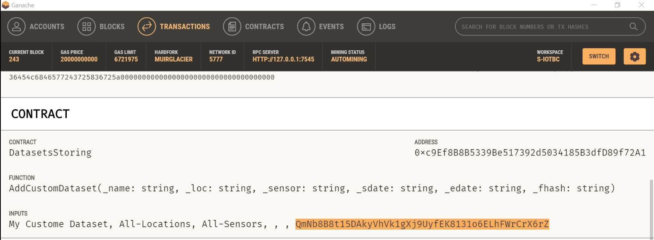

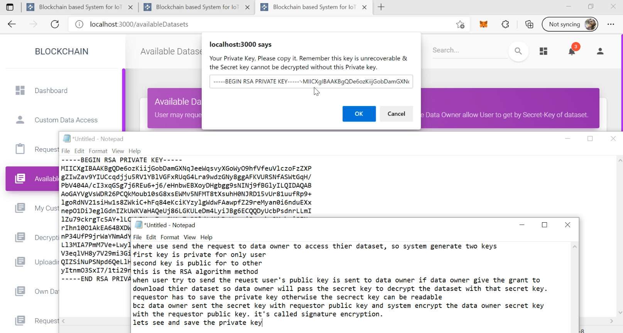

After getting accessing from data owner for a dataset, use can decrypt the dataset dynamic security key with private key then decrypt the dataset with this decrypted after downloading from the decentralized storage

